` 2020-2021

Half Pint Preschool Themes

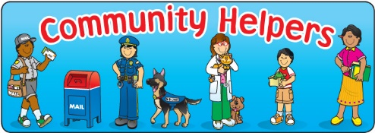
September

- Back to School! 9/8 - 9/11 Color: Blue
- All About Me and My Family 9/14 – 9/18 Shape: Square
- You’ve Got a Friend in Me! 9/21 – 9/25 Letters: A, B
- Mind Your Manners 9/28 – 10/2 Numbers: 0, 1
Daycare will be closed on September 7th
October
- Fun on the Farm 10/5 – 10/9 Color: Orange
- Fall/Tree’s 10/12 – 10/16 Shape: Circle
- Stop, Drop and Roll 10/19 – 10/23 Letters: C, D
- Pumpkins/Halloween 10/26 – 10/30 Numbers: 2, 3
See Note Attached
November
- Happy, Sad, Angry, Glad! 11/2 – 11/6 Color: Brown
- Community Helpers 11/9 – 11/13 Shape: Rectangle
- Lets’ Talk Turkey and 11/16 - 11/20 Letters: E, F
- Thanksgiving 11/23 & 11/24 Numbers: 4, 5
Daycare closed on November 25th, 26th and 27th
See Note Attached
December
- Our 5 Senses 11/30 – 12/4 Color: White
- People Around the World 12/7 – 12/11 Shape: Triangle
- Merry Christmas! 12/14 – 12/18 & 12/21 – 12/23 Letters: G, H
- Happy New Year! 12/28 - 12/30 Numbers: 6, 7
Daycare closed on December 24th, 25th and 31st
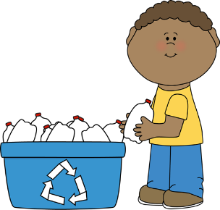

January
- ‘Dem Bones/Our Body 1/4 – 1/8 Color: Black
- Artic Animals 1/11 – 1/15 Shape: Arrow
- Winter Fun 1/18 – 1/22 Letters: I, J
- Opposites 1/25 – 1/29 Numbers: 8, 9
Daycare closed January 1st
February
- Groundhog’s Day/Shadows 2/1 – 2/5 Color: Red
- Valentine’s Day/Love/Respect 2/8 – 2/12 Shape: Heart
- Our Proud Presidents 2/15 – 2/19 Letters: K, L
- Sparkly Smile/Dental Health 2/22 – 2/26 Numbers: 10, 11
March
- One Fish, Two Fish/Dr. Seuss 3/1 – 3/5 Color: Green
- Dinosaur Dig 3/8 – 3/12 Shape: Diamond
- Lucky Leprechauns 3/15 – 3/19 Letters: M, N
- Spring is Here! 3/22 – 3/26 Numbers: 12, 13

April
- “Hoppy” Easter 3/29 – 4/1 Color: Purple
- Beautiful Birds 4/5 – 4/9 Shape: Oval
- Let’s Be Safe! 4/12 – 4/16 Letters: O, P, Q
- Ponds and Frogs 4/19 – 4/23 Numbers: 14, 15 ,16
- Recycling/Saving Our Planet 4/26 – 4-30
Daycare Closed April 2nd
May
- May Flowers 5/3 – 5/7 Color: Yellow
- Butterflies & Bugs 5/10 – 5/14 Shape: Star
- Let’s Go to the Zoo 5/17 – 5/21 Letters: R, S
- Under the Big Top 5/24 – 5/28 Numbers: 17, 18
Daycare closed May 31st

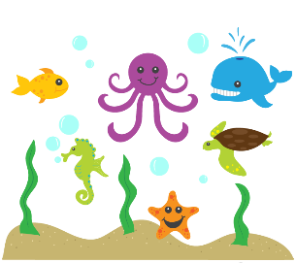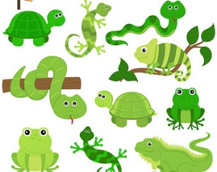
June
- Lets’ Go Camping! 6/1 – 6/4 Color: Gray
- Transportation 6/7 – 6/11 Shape: Hexagon
- Teddy Bear Fun (Bears) 6/14 – 6/18 Letters: T, U
- A Look into Space 6/21 – 6/25 Numbers: 19, 20
July
- Celebrate America 6/28 – 7/2 Color: Pink
- Picnic/Ants 7/6 – 7/9 Shape: Octagon
- Ocean Life 7/19 – 7/23 Letters: V, W
- Construction 7/26 – 7/30 Numbers: 21, 22
Daycare closed July 5th since the 4th is on a Sunday and the week of July 12th – 16th
August
- Summer in the Sun 8/2 – 8/6 Colors: Review
- Sports/Be a Good Sport 8/9 – 8/13 Shape: Review
- We ♥ Minnesota 8/16 – 8/20 Letters: X, Y, Z
- Reptiles 8/23 – 8/26 Number: 23, 24, 25
- Graduation/Kindergarten Rocks! 8/30 – 9/3
Daycare closes at 4:30pm on September 2nd for graduation and we are closed August 27th

*Attached is a list of our holidays and vacation/personal days which we will be closed. Please keep this list handy and/or write these days on your calendar, that way you can plan and find alternative care.

**Sydney (Ms. Christine’s daughter) is due to give birth October 29th and Ms. Christine would like to take a week off to help her with her new addition. Since it is hard to know exactly when she will give birth, we are thinking it will be the beginning of November. We know it is an inconvenience not knowing exactly which week it will be, but we thank you for your flexibility and understanding!

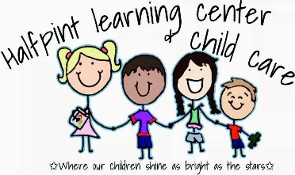

Half Pint is Closed for the following Holidays & Vacation/Personal Days:

Monday, September 7th Labor Day
Wednesday, November 25th Personal Day
Thursday, November 26th Thanksgiving
Friday, November 27th Day after Thanksgiving
Thursday, December 24th Christmas Eve
Friday, December 25th Christmas Day
Thursday, December 31st New Year’s Eve
Friday, January 1st New Year’s Day
Friday, April 2nd Good Friday
Monday, May 31st Memorial Day
Monday, July 5th For Independence Day (Since the 4th is on a weekend, our holiday is on the 5th)
Monday, July 12th – Friday, July 16th We are on vacation (Summer Break)
Friday, August 27th Personal Day
**Thursday, September 2nd Close at 4:30p.m. Preschool Graduation

